

NOTICE OF COMPLETE APPLICATION AND PUBLIC MEETING

TO INFORM THE PUBLIC OF A ZONING BY-LAW AMENDMENT

TAKE NOTICE that the Council for The Corporation of the Municipality of Powassan has received a complete application under Section 34 of the Planning Act, R.S.O. 1990, c.P. 13 as amended, to inform the public of a proposed Zoning By-law Amendment.

The public meeting is being held for the application described below to enable interested members of the public to understand and comment on the proposed Zoning By-law Amendment application.

DATE AND LOCATION OF PUBLIC MEETING

File #: 2026-03
Date: Tuesday April 7, 2026
Time: 6:00 pm
Location: Municipality of Powassan – 252 Clark Street

PURPOSE AND EFFECT OF THE ZONING BY-LAW AMENDMENT

The purpose and effect of the proposed Zoning By-Law Amendment is to amend the Restricted Area Zoning (By-Law No. 2003-38), as amended, for the lands described as Part of Lots 19 and 20, Concession 13 (Himsworth); PIN 52207-0289, Powassan, (Civic Address: 118 Highway 534), in the Municipality of Powassan to fulfill a condition of consent to repeal By-law 2009-44 and rezone the subject lands for their intended uses.

The application, if approved, would rezone the subject lands from General Industrial Exception Five (M1-5) and Multiple Residential (RM) to Rural (RU) and a General Industrial Exception Zone (M1-X) to permit the continued use of a Contractor’s Yard.

ADDITIONAL INFORMATION

A key map showing the land to which the proposed amendment applies is provided with this notice. Any person who participates in the meeting can speak to the application with questions, concerns or support.

No one other than the applicant, the municipality, certain public bodies and the Minister may file an appeal of the decision.

If you wish to be notified of the decision of the Council for the Corporation of the Municipality of Powassan in respect to the proposed Zoning By-law Amendment, you must submit a written request (with forwarding addresses) to the Clerk of the Municipality of Powassan at P.O. Box 250, 250 Clark Street, Powassan, Ontario, P0H 1Z0.

Additional information regarding the proposed amendment is available to the public for inspection at the Municipality of Powassan Municipal Office located at 250 Clark Street on Monday to Friday, between the hours of 8:30 a.m. and 4:30 p.m. please call (705) 724-2813.

Mailing Date of this Notice: March 17, 2026

Kimberly Bester, Deputy-Clerk
Municipality of Powassan
kbester@powassan.net

Location Map

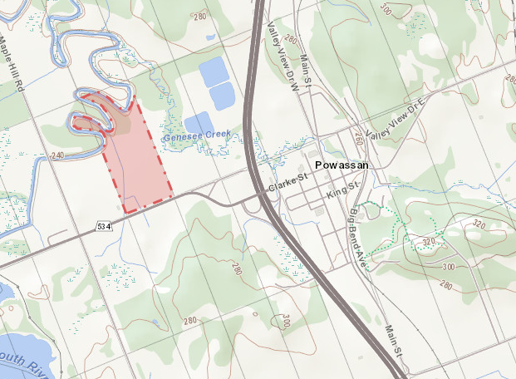
Subject Property

N

